***CURRICULUM VITAE***

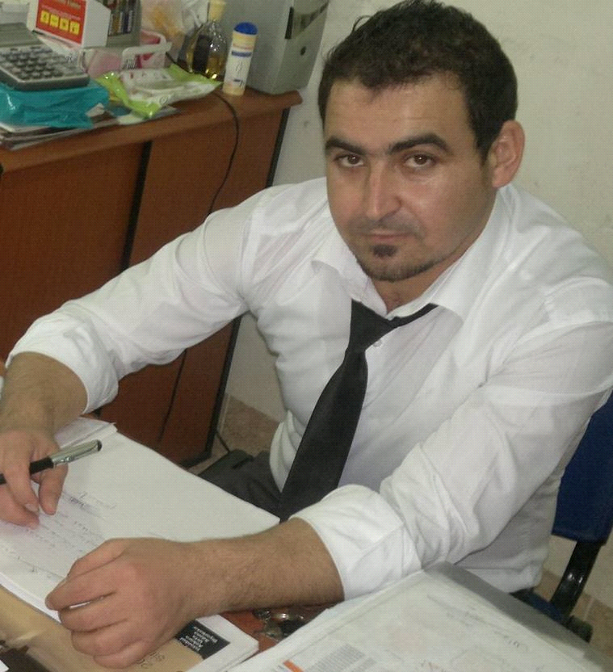

***Personal information:***

***Mohammed Mustafa Mahmoud***

Erbil, 32 park, Iraq

***00964 (0) 7828353067***

***abomsta1986@gmail.com***

Sex: Male Date Of Birth: 01,11,1986 Nationality: Syrian

**Work experience:**

2011-2012 English language Teacher

2013 Translator in Korea Kurdistan city

2014 Manager in Mis supermarket

2015-2016 Receptionist in Deadman Hotel Erbil (five stars)

2017 worked with MSF Organization as following:

* Administered surveys on Non-Communicable Diseases, Trauma and Stressors, and two different Mental Health Screening tools 2017
* Referred cases to psychologists based on positive screening scores 2017
* Ensured high quality of data collected and maintained confidentiality of all individuals surveyed 2017
* Trained in Psychological First Aid, common mental health disorders, and how to conduct sensitive interviews 2017
* Used Kobocollect on tablets to collect survey data 2017

2017-2019 Sales and marketing supervisor in GSL (telecom)& Triple application company (advertisement )

Training course attended

-Trained in Psychological First Aid, common mental health disorders, and how to conduct sensitive interviews 2017

- getting training about management and solving problem in M-SELECT institute2018

**Education:**

October 2012 - Bachelor of Literature, English Literature Department

Faculty of Literature, Damascus University, Damascus -Syria

JULY 2012 -ICDL Certificate from AL-Ruha institute - Qamishli ,Syria

International computer Driving License

|  |
| --- |
| **Mother Tongue(s)**  Kurdish |
| Other Language(s)  **English** UNDERSTANDING SPEAKING WRITING Listening Reading Spoken Interaction Spoken production  A1 A1 A1 A1 A1  English Literature Degree -Damascus University |
| **Arabic** UNDERSTANDING SPEAKING WRITING Listening Reading Spoken Interaction Spoken production  A1 A1 A1 A1 A1 |
| **Turkish**  UNDERSTANDING SPEAKING WRITING Listening Reading Spoken Interaction Spoken production  B3 B2 B2 B2 B3 |
| **levels** C3 Basic user B2 Independent user A1 Proficient user |

Communication skills: excellent communication skills gained through my experience in the multi culture work environment

Job related skills good Command of teaching &translation management

**Computer skills:**

Word-excel-access-power point -internet

-opera, omega, sky, systems

**Other information:**

*-Abiding the working hours, and Respect my superiors and fellows, I have the pleasure to be one member of your team and hope my qualification shall meet your satisfaction*

**Best regards & thanks**